Notice of Intent to Award
Posting Date: January 20, 2022

This is a statement of intent to award a contract and becomes the official statement of award effective 8:00 AM on February 1, 2022 unless otherwise suspended or canceled. Vendors are cautioned not to begin work on the contract or incur any costs associated with the contract prior to the effective date of the contract. The University of South Carolina assumes no liability for the expenses incurred by vendors prior to the effective date of the contract.

Bidders right to protest as listed in Section 11-35-4210 in the South Carolina Consolidated Procurement Code applies to this award. Protest to be filed in writing with:

Chief Procurement Officer

Materials Management Office

1201 Main Street, Suite 600

Columbia SC 29201

Facsimile: 803-737-0639

Email: protest-mmo@mmo.state.sc.us
Solicitation Number: |  | Event No. 210046-04
Issue Date: | June 30, 2021
Opening Date: |  |  | January 20, 2022
Description: | Integrated Marketing and Public Relations

Initial Contract Term: August 31, 2021 through August 30, 2022

Maximum Contract Term: February 1, 2022 through August 30, 2024

Estimated Potential Value of Contract: $__3,000,000.00________________________________

Awarded to: Huggins Partners, LLC

5034 Furman Ave.

Columbia, SC 29206

Lot 1 – Marketing Strategy Services - $175.00 per hour

*NOTE: This is a partial list of awards. Additional awards will be made pending further evaluation,

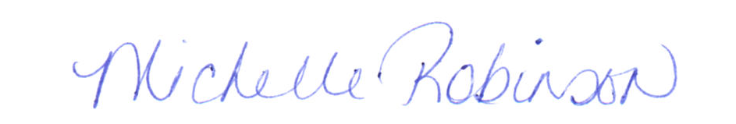

Michelle Robinson, CPPB

Procurement Manager

